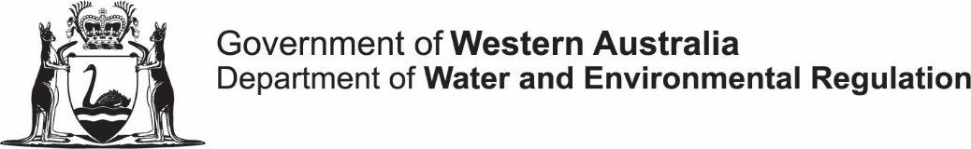

Community Water Supply Program

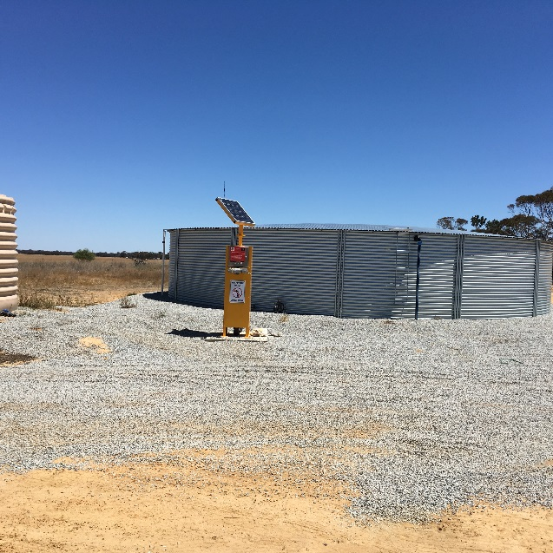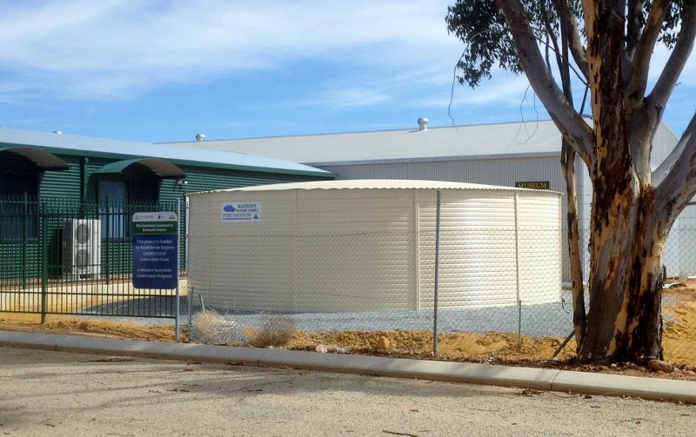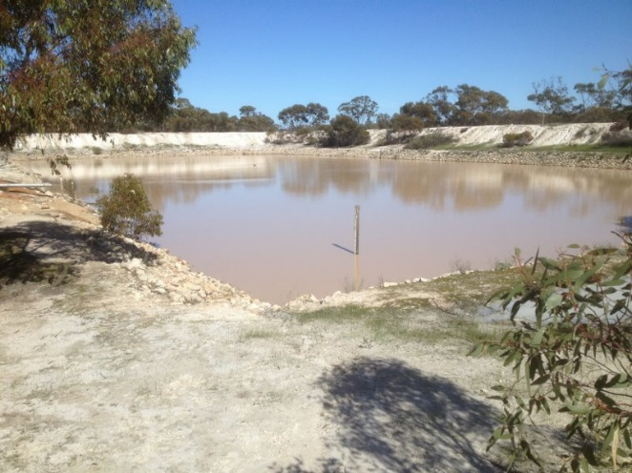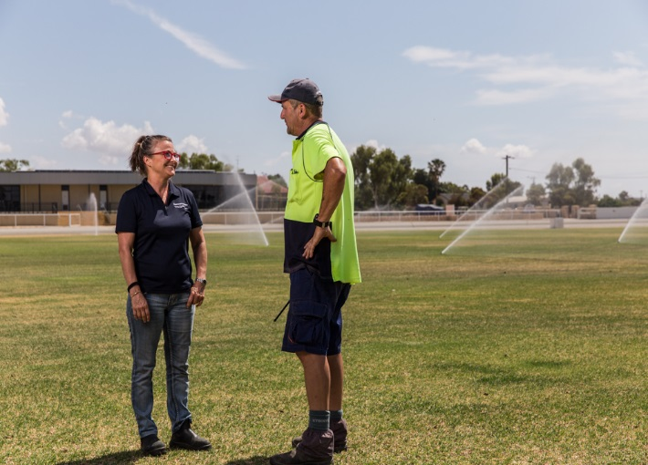

Community Water Supply program Project Plan
Please note – all blue text are instructions only and should be removed when completing the template.
Project plan
This project plan needs to be submitted to the department along with the completed application form and supporting attachments for your application to be assessed. The plan must be completed using this template. Due to time constraints applications that are not completed in the required templates will be returned. This plan forms part of the documentation that is a requirement for project approval by the Minister for Water.
The level of detail required is based on the complexity of the proposed project. It is recommended that you discuss your proposal with the Department of Water and Environmental Regulation as early as possible in this process.

Scope

Project description
Provide a description of the project and its components (e.g. construction of new tanks or dams). Provide details if the project receives funding from other sources.

Purpose
Describe the purpose of the project.

Benefits
Provide details of the benefits of the project including social, economic and environmental benefits.

Design
Provide a detailed design for the project. This may include, but is not limited to, design drawings, specifications tables, material lists. This information may be provided as attachments that must be referred to in this section. All components of the proposed works and infrastructure to be installed should be detailed.

Project location
A map of the project location must be provided either in this section or as an attachment. If attached, the name of the attachment must be detailed in this section. This should include a location and other relevant maps of the project. Additionally please complete the table below.
Location
Address
Cross roads
Coordinates

Out of scope
Describe any aspects of the proposed works and infrastructure that are not part of this proposal.

Feasibility
In this section you must demonstrate the feasibility of the project. This section should be discussed with the Department of Water and Environmental Regulation and may include:
- Details of site investigations
- The adequacy of the site to meet proposed project design requirements and specifications
- Examples of previous similar successful projects
- Statutory obligations
- Test drilling/pit results – depth, soil testing, foundation design or stability analysis
- Rainfall and evaporation data
- Catchment and runoff data
- Hydrological investigations (for groundwater resources) – yields, aquifer type, water balance
- Topographic survey data – contour maps, datum
- Dam design capacities and specifications , spillway design
- Other infrastructure specifications – pumps, bores, tanks, pipelines – including calculations and location details
The level of reporting and field investigations required should be discussed with the department during the early development or conceptual stages of the project.

Project timeline and work breakdown
A detailed timeline of project works and major milestones should be provided in this section. This may be provided as an attachment and the name of the attachment referenced in this section. Preferably this will be provided in the form of a Gantt chart.
A works breakdown structure must be provided detailing who is completing the work.

Budgets
- Specify all sources of funding including cash and “in kind” contributions.
- Clearly indicate funding requested.
- Clearly describe how costs have been estimated

- Written quotes must be provided for all items over $10 000. Attach all quotes to the application and refer to in this section
Budget – Project cost breakdown

Work item number | Work description  (including costs per hour or unit)  Example provided | Applicant cash contribution | Applicant in-kind contribution | CWSP Grant | Total
1 | Earthworks to excavate 2500 m³ dam (@ $X/m³)
2 | Supply 2.0 km of DN200 mm PE/PVC lilac “reclaimed water” arterial pipeline (@ $X/m)
3 | Excavate trench and bury pipeline using shire earthmoving equipment  (In-kind contribution @ $X/m)
4 | Supply 2 x 250 kL steel water storage tanks (@ $X per unit)

Maintenance and ongoing operational costs
Provide details of the ongoing maintenance and operational costs. This should include who is responsible for ongoing operation and maintenance of the installed infrastructure. Any agreements should be attached.

Procurement plan
Provide details of the procurement processes that will be undertaken for the proposed works, goods and services related to the project proposal.

Roles and responsibilities
Provide details of the roles and responsibilities for this project. This must include details of project management responsibilities and resumes for key technical and management personnel.

Environmental considerations
Detail any environmental risks for the project and mitigation actions.

Clearances, approvals and agreements
Detail all clearances, approvals and agreements that have been gained.
Detail all clearances, approvals and agreements that still need to be obtained and provide a plan for those that are still outstanding.
Details of affected landholders and written evidence of agreements must be provided.

Community support
Detail the level of community support for this proposal, how level of support has been determined. Provide any written supporting documentation as an attachment.

Risks
Identify risks and their management. A minimum of three risks and no more than seven should be identified in this section.

Application endorsement
Local government support for the project. By signing this form you are confirming that your local government is supportive of this application.

Local government name
Name of CEO
Signature of CEO
Date
Name of president of LGA
Signature of president of LGA
Date

Applicant sign-off for the project (do not complete if applicant is local government)

Name of organisation
ABN (if applicable)
Name (must be authorised to sign on behalf of the organisation)
Position
Signature
Date

Completed forms should be sent by email to ruralwater@dwer.wa.gov.au

For further information please contact the Rural Water Planning section on Telephone 1800 780 300, Officer Tracy Calvert 98410122, or 0428180240 or ruralwater@dwer.wa.gov.au

