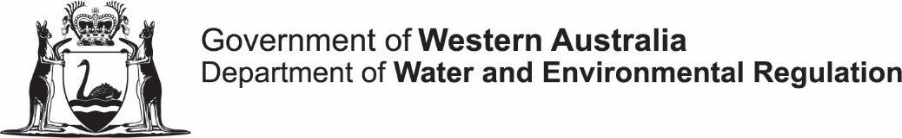
Community Water Supply Program

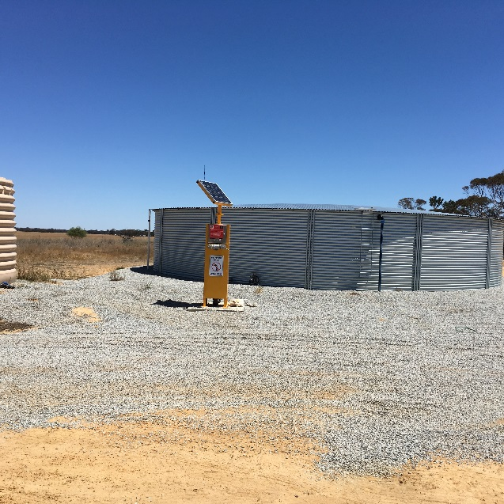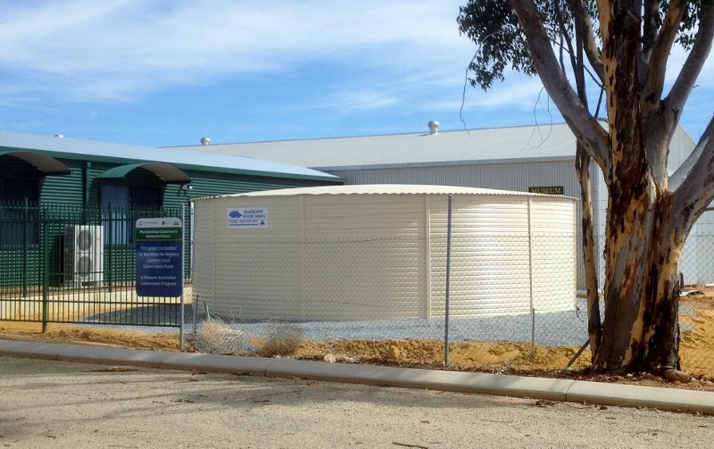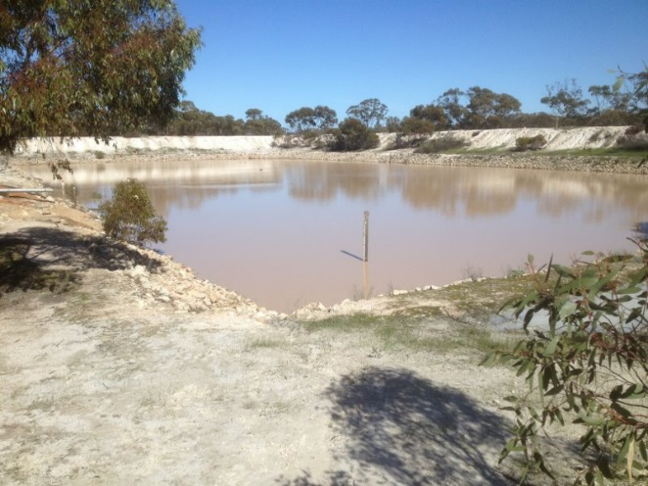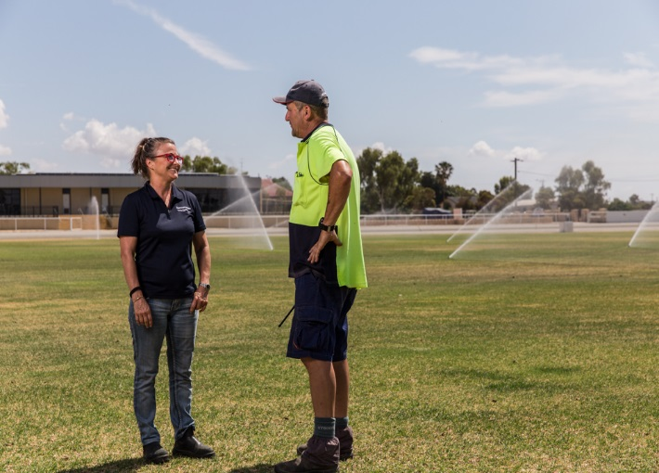

Department of Water and Environmental Regulations
Rural Water Planning
7 Ellam St, Victoria Park
Perth Western Australia 6100
Telephone 1800 780 300
ruralwater.water.wa.gov.au
www.water.wa.gov.au

© Government of Western Australia 2019

January 2019

This work is copyright. You may download, display, print and reproduce
this material in unaltered form only (retaining this notice) for your personal, non-commercial use or use within your organisation. Apart from any use as permitted under the Copyright Act 1968, all other rights are reserved. Requests and inquiries concerning reproduction and rights should be addressed to the Department of Water and Environmental Regulations.

Disclaimer
This document has been published by the Department of Water and Environmental Regulations. Any representation, statement, opinion or advice expressed or implied in this publication is made in good faith and on the basis that the Department of Water and Environmental Regulations and its employees are not liable for any damage or loss whatsoever which may occur as a result of action taken or not taken, as the case may be in respect of any representation, statement, opinion or advice referred to herein. Professional advice should be obtained before applying the information contained in this document to particular circumstances.

Introduction

What is the Community Water Supply Program?
The Community Water Supply Program (Program) is a State Government initiative administered by the Department of Water and Environmental Regulation (DWER).
The Program objective is to assist broad-acre farming communities to establish or improve non-potable water supplies to reduce reliance on potable water supplies for non-potable needs, increase public amenity, ensure water is available for emergencies and to be better prepared for periods of low rainfall. Non-potable water supplies are those that have not been treated to meet drinking water standards.
The focus of the Program is to provide assistance in areas that have a history of water deficiency or where on-farm and non-potable community water supplies are unreliable and unable to meet the needs of local landholders or the community.
Funding can be sought for projects that will take advantage of local non-potable water sources for community or emergency farmland use.
Funding support for these projects depends on the nature of the work and the intent of the project.

Key information

How much money is available?
Up to $100 000 is available for each project and all funds must be acquitted within two years of award.

When can I apply?
The Department of Water and Environmental Regulation’s Rural Water Planning Team can provide advice on timing of funding rounds. The team can be contacted at ruralwater@dwer.wa.gov.au or 1800 780 300.

How do I submit applications?
Applications should be submitted via email to ruralwater@dwer.wa.gov.au. All applicants will be notified by email confirming that their application has been received. If you do not receive an email notification immediately after submitting your application please contact us at ruralwater@dwer.wa.gov.au or 1800 780 300.

Applicants must submit an application form and project plan in the templates provided. Applications will be returned if they are not completed in the required templates. At any stage during the assessment process the Department of Water and Environmental Regulation may request further information or clarification from the applicant.
Please contact the Rural Water Planning team to request the latest application form and project plan template.

Contacts
For all queries please contact the Rural Water Planning team.

Phone: 1800 780 300
Officer: Tracy Calvert 98410122 or 0428180240
Email: ruralwater@dwer.wa.gov.au
Website: www.dwer.wa.gov.au

Key Criteria

Who can apply?
The following groups are eligible to apply:
- local government authorities
- community groups that are incorporated bodies.

All applications must have the support of the shire and the application forms must be signed by the shire president and CEO.

Previous Community Water Supply grant recipients are reminded that they need to ensure they are up-to-date with all reporting and/or acquittal requirements at the time of application. Applicants with projects that have outstanding progress reports or final reports will not be considered for funding. Applicants may apply for more than one grant.

Applicants must have an ABN and be a legal entity to be eligible for funding.

It is not essential that applicants are registered for GST, however it is important to note that you will not be able to claim GST if not registered. This will be taken into consideration during the assessment process.

Who can’t apply?
The following entities are not eligible to apply but may partner eligible applicants:
- state government agencies
- businesses
- tertiary education institutions
- individuals.

What areas are eligible for funding?
The table below identifies shires that are eligible to apply under the program.

Albany | Corrigin | Goomalling | Lake Grace | Nungarin | Wagin
Beverley | Cranbrook | Greater Geraldton | Merredin | Perenjori | Wandering
Boddington | Cuballing | Irwin | Mingenew | Pingelly | West Arthur
Boyup Brook | Cunderdin | Jerramungup | Moora | Plantagenet | Westonia
Brookton | Dalwallinu | Katanning | Morawa | Quairading | Wickepin
Broomehill - Tambellup | Dandaragan | Kellerberrin | Mt Marshall | Ravensthorpe | Williams
Bruce Rock | Dowerin | Kent | Mukinbudin | Tammin | Wongan-Ballidu
Carnamah | Dumbleyung | Kojonup | Narembeen | Three Springs | Woodanilling
Chapman Valley | Esperance | Kondinin | Narrogin | Toodyay | Wyalkatchem
Chittering** | Gingin** | Koorda | Northam | Trayning | Yilgarn
Coorow | Gnowangerup | Kulin | Northampton | Victoria Plains | York
** The communities in the Chittering and Gingin shires are only eligible if they are east of the Brand Highway

What are the priority funding objectives?
For a project to be considered it must provide clear benefits to the community. The priority funding objectives for the program are provision of non-potable water supplies for:
- increasing public amenity through the irrigation of public open space such as ovals, gardens and parks
- establishing or upgrading emergency farm water supplies for livestock
- reducing reliance on scheme water.

How much co-contribution must applicants make?
Applicants must contribute a minimum of 30 per cent of the total project cost. Greater co-contribution ratios will be held in higher regard. This contribution may include in-kind funding.
Some examples of in-kind contributions include the use and operation of specialised equipment (for example – earthmoving equipment) and technical, professional and expert services (for example the use of shire engineering staff and works crews).
Funds received from other state government funding programs cannot be used to satisfy the Community Water Supply program co-contribution requirement.

Who is responsible for ongoing operation and management?
To be eligible for funding the responsibility for ongoing maintenance must be clearly detailed and any agreements required be in place. The Department of Water and Environmental Regulation will not be responsible for the ongoing operation, management and associated costs of installed infrastructure.

It is important that community water supplies are maintained following the completion of the project. Where appropriate the Department of Water and Environmental Regulation recommends that projects consider systems to monitor usage and allow for user payments towards ongoing maintenance costs.

Application Information

What is the application process?
Applicants are required to contact the Department of Water and Environmental Regulation to discuss the proposed project prior to applying. The level of detail required in applications is dependent on the complexity and nature of the proposed project.

Step 1: Applicants submit an application form and project plan to the Department of Water and Environmental Regulation in the standard templates. Templates can be accessed on request from the rural water team at ruralwater@dwer.wa.gov.au or by calling 1800 780 330.
Step 2: The application is assessed for eligibility, benefits, cost and risk. A recommendation is made to the Minister for Water. Following the Minister's decision, successful and unsuccessful applicants will be advised accordingly.
Step 3: A Deed of Agreement is negotiated between the Department of Water and Environmental Regulation and the applicant. The Deed of Agreement includes project timelines and schedules.
Step 4: Project delivery is tracked against the Deed of Agreement. Milestone payments are made dependent on evidence of completed work as agreed in the Deed of Agreement.
Step 5: A closing report is submitted to the Department of Water and Environmental Regulation and, provided all requirements are met, the final payment is made.

Project feasibility
It is important to consult the Department of Water and Environmental Regulation in the conceptual stages of the project to ensure that the project will meet the expectations and objectives of both the community and the government. The level of planning required for a project will depend on the complexity, budget and location of the proposed works.
Suitable sites for proposed works should be identified and tested to ensure they will meet all design requirements and specifications. Field investigations will assist in decision making and should inform final designs. For projects affecting dams, it is essential that the structure is sound and represents no threat to public safety.
Geotechnical site investigations may need to include:
- the drilling of proposed dam sites
- soils and materials testing
- groundwater investigations
- topographical surveys.

Subsurface investigations may be needed to provide information on soils, construction materials, geology and water table elevations. Where required, drilling and pit testing results should be presented on a plan view and plotted on profiles. Other information such as aerial photography, topographic maps, property ownership details, previous project plans, local surveys and legal documents should be presented.
Detailed final designs are not required in the application and it is acceptable for preliminary budget estimates to be provided. However, your proposal must be technically feasible and the cost realistic. The need for any statutory approvals should be clearly identified in the early stages of project development and, should the grant application be approved, payment will be conditional upon these approvals being obtained prior to implementation.

Project planning and management
The application must show evidence of adequate planning and the applicant’s capacity to implement and manage the project, including a methodology that demonstrates how outcomes will be achieved and a realistic timeline.
The proposal must include a plan and budget for the proposed project. The plan must demonstrate that the delivery of the project from the start to completion has been carefully considered and planned.
The plan and budget must demonstrate value for money and include a sufficient level of detail and explanation to assist an informed financial decision.
The applicant must demonstrate that all key personnel including project managers, consulting experts and technical/operational staff have the experience and expertise to deliver the project.

Community involvement
An important component of the Community Water Supply Program is the requirement for local community consultation in the planning and implementation of the project.
The shire must be included in the development of the funding proposal, as they are required to endorse the application.
Your application needs to show:
- who you have engaged in developing this proposal (this may include project partners)
- how it has or will engage the community (this may include project partners)
- an estimate of participant numbers at proposed activities
- communication and marketing activities associated with the promotion of the project
- how the project will be accessible to participants and communities, or to a specific target group

Partnerships
Project proponents that work in partnership with other organisations will be highly regarded.
A partnership refers to an arrangement where a second organisation (not the applicant) contributes something toward the project including cash or in-kind contributions. Examples of potential partners include local government authorities, government agencies, non-government organisations, education institutions or community groups.
A letter of commitment from each identified partner outlining the contributions they have agreed to provide must accompany your application.

Consortium arrangements
A consortium consists of two or more organisations that work in partnership to share responsibility, resources, and outcomes for the proposed project.
A consortium must nominate a lead organisation which shall also be the applicant organisation. The applicant organisation must be eligible to apply. It must take responsibility for the management and delivery of the project and the conduct of personnel delivering these services.

The participating organisations will need to agree how the consortium will operate including how the project activities will be delivered by partners across different locations.

Other grant applications
Applicants must disclose the details of other grant applications for the same project (area and/or activity) as the subject application.
After applying, if you are successful with other grant applications, you are required to notify the Department of Water and Environmental Regulation immediately as part of your assessment.

If you are successful in your grant application and there are multiple funding sources for the project, you will need to provide evidence of these funding sources and the project activities that they relate to.

Consultants and contractors
Grant funds can be used to engage consultants and contractors for specialist activities and tasks that applicants do not have the capacity to complete as part of their delivery of the project.
Where known applications should include the name and qualifications of the consultant(s) or contractor(s) and detail the scope of their activities and how their involvement will contribute to the project’s successful delivery.

Supporting material
Applicants should ensure that all supporting material referred to in the application is attached to the application form including:
- a clear, comprehensive budget
- signed letters of commitment from individuals and organisations who have agreed to make a tangible contribution (cash or in-kind) to the proposed project. Please note, these contributions must be identified in the letter and must match items in the project plan and budget
- signed letters of commitment from individuals and organisations who are supportive of the proposed project
- maps, diagrams and photos as appropriate.

Project implementation
The Department may require detailed plan specifications for large scale or complex infrastructure. In these circumstances the final design and specification documents will need to be submitted to the Department of Water and Environmental Regulation for approval prior to the commencement of any on-ground works
All plans should establish technical requirements of the proposed works and be adequate for contracting. The costs associated with the work should be included in the initial budgeting estimates.

Application Assessment
The Department of Water and Environmental Regulation will use the information provided in individual applications to determine a project’s eligibility and priority for funding.

Applications will be assessed and prioritised according to eligibility, benefits, cost and risk.

Eligibility assessment
Applications that meet the following eligibility criteria will be regarded favorably:
- Climate change impacts – greater weight will be given to project proposals in areas that are significantly affected by climate change. The assessment of applications will take into consideration trends in declining rainfall and the Shire’s history of water deficiency declarations.
- Availability and reliability of scheme water supplies – the availability of scheme will be considered including the reliability and cost of this supply.
- Shire water management strategy – weight will be given to projects that align with the shire’s water management strategy (or a similar strategic planning document)
- Community engagement and support – weight will be given according to the level of support for the project from the community.
- Areas with a history of Water Deficiency Declarations and water carting for livestock.

Benefits assessments
The assessment will consider the benefits that the project provides to the community and the state. In assessing benefits the application form and project plan will be referred to.
Recognised benefits will include the projects:
- contribution to water security of the town now and into the future
- reduction in reliance on scheme water supplies and associated cost benefits
- improvement to emergency water supplies for farms and firefighting
- contribution to public amenity including watering of parks, gardens and public open space
- value for money.

Risk assessment
Applications will be assessed to determine the level of risk associated with funding the project. The risk factors that will considered are those that may prevent the project being delivered on budget, and on time and from being of sufficient quality.
Information provided in the application form and project plan will be used to determine the level of risk that the project presents including:
- feasibility and design work that demonstrates the suitability of the project site selection and the viability of proposed infrastructure
- timelines, plans and work breakdown
- demonstrated project management capability
- evidence of clearances and approvals
- evidence of endorsement and support for the project
- budgets
- commitments to ongoing maintenance and operational costs.

