Community Water Supply Program

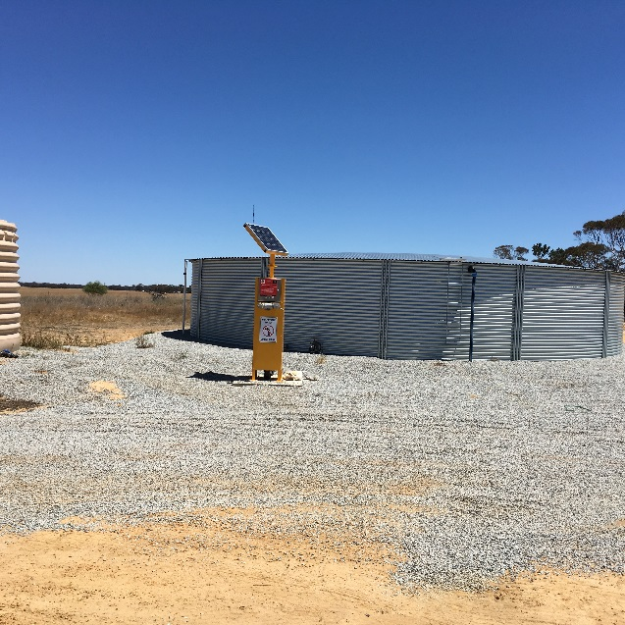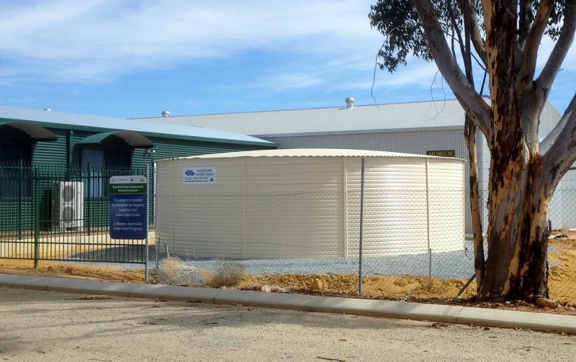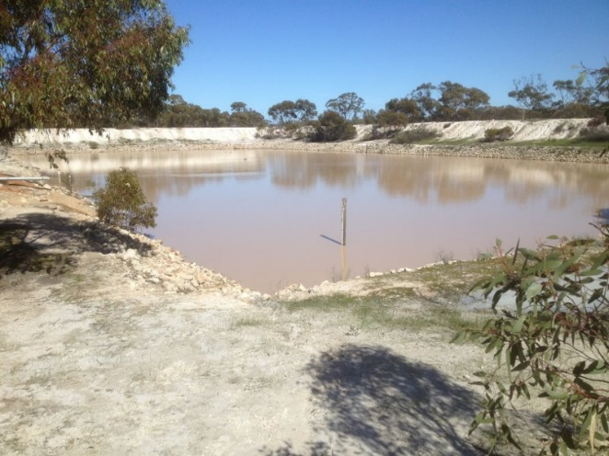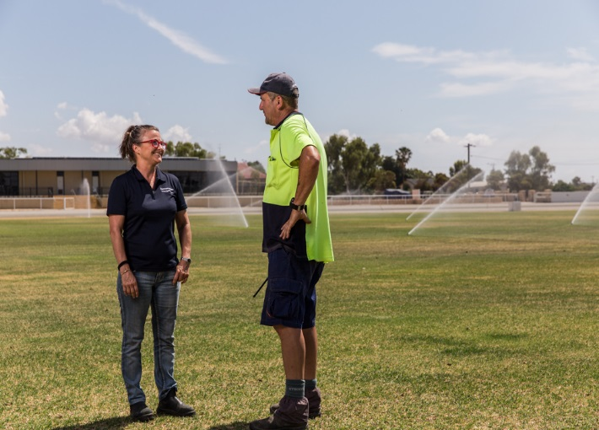

Community Water Supply Program application form
Note: Please identify all volumes in kilolitres (kL)

Project title:
Click here to enter text.

Project summary
Provide a brief summary of the project and the purpose. The summary should be between 150 to 300 words.
Click here to enter text.

Part A - Proponent details

Name of local government area (LGA), or group making this application | Click here to enter text.
Contact (Project Manager) | Click here to enter text.
Address | Click here to enter text.
Phone | Click here to enter text.
Fax | Click here to enter text.
Email | Click here to enter text.

Eligibility assessment
The Department of Water and Environmental Regulation will use the information provided in this section as part of the eligibility assessment. Information must be provided in this form and justified by supporting documentation. It is mandatory to complete all sections with an appropriate level of detail. Only referring to supporting documentation will not be accepted.

Is the shire within the dryland agricultural area receiving less than 600 mm average rainfall?
(Please refer to information for applications document for a list of shires)
☐ Yes ☐ No (please contact the Department of Water and Environmental Regulation to discuss your eligibility)
Click here to enter text.

Does this proposal have the support of the shire?
☐ Yes ☐ No
Click here to enter text.

Declining rainfall and water deficiency declarations
Is there a trend of declining rainfall in the shire over the past 30 years? Please provide reference data as an attachment and refer to the attachment in the comments box below.
☐ Yes ☐ No
Is there a history of water deficiency declarations (please refer to the guidelines for a definition) and if so how many in the past 10 years?
☐ Yes ☐ No

Click here to enter text.

Contribution to water security
What are the current issues with water availability?
Click here to enter text.

How will this project contribute to water security?
Click here to enter text.

What volume of water will be made available annually by the proposed project?
Click here to enter text.

What is the current and projected demand?
Click here to enter text.

Availability and reliability of scheme for current and intended purposes

Detail the reliability of scheme water. This includes any issues with pressure or availability.
Click here to enter text.

Reduction in reliance on scheme water
Will the project reduce reliance on scheme water?
☐ Yes ☐ No - please proceed to next section
What volume of scheme water is currently utilised for the intended purpose? (e.g. if the project will provide water to irrigate the football oval, how much scheme water is currently used to irrigate the oval?)
Click here to enter text.

What is the expected scheme water saving (volume and cost) from implementing this project?
Click here to enter text.

Availability of alternative non-potable sources
Provide details of existing non-potable water sources utilised in the community.
Click here to enter text.

Provide details of all existing non-potable water sources that are not utilised by the community
Click here to enter text.

Provide an explanation as to why the new source is required and why it is the best option
Click here to enter text.

Improvement in water for emergency farmland water supplies
Will the project make water available for emergency farm use?
☐ Yes ☐ No - please proceed to next section
Click here to enter text.

How many strategic emergency farm water supplies are available within 40km? Provide details of the volumes of water available.
Click here to enter text.

What volumes will be made available for emergency farmland water supplies? How will this water be accessed and what infrastructure will be installed to support emergency farm use? How many farmers will benefit from this supply?
Click here to enter text.

Provision of water for public amenity
Will the project provide water for public amenity such as watering public open space, ovals, street gardens, and public sporting facilities?
☐ Yes ☐ No - please proceed to next section
What is the expected benefit from this water (e.g. will it be used for facilities that are currently under watered, or where water is not available?)
Click here to enter text.

What volume of water will be available for improving public amenity? What volume will be used for public amenity purposes?
Click here to enter text.

Environmental benefits
Does the proposed project provide any environmental benefits? If so provide details.
Click here to enter text.

Other alternative uses for the water
Are there any other uses for this water not detailed in previous sections?
☐ Yes ☐ No - please proceed to next section
Describe the use and provide details of the volume of water that will be available for this purpose.
Click here to enter text.

Community engagement and support
How has the community been engaged in this project?
Click here to enter text.

What is the level of support from the community for this project, and how is this support measured? Provide written supporting documentation as an attachment to your project plan.
Click here to enter text.

Detail the number of people who will benefit from the project and describe how they will benefit.
Click here to enter text.

Shire water management strategy
Does the shire have a water management strategy (or similar) and if so how does this proposal fit into the strategy?
Click here to enter text.

Percentage co-contribution of the applicant to this project. Detail contribution of all parties.
Provide summary details of the percentage co-contribution to this project including in-kind.
Click here to enter text.

Project timeline
Provide summary details of the project’s estimated commencement and completion dates.
Click here to enter text.
Are there any factors that influence the timing of this project (e.g. seasonality, availability of workforce?)

Application endorsement

Local government name | Click here to enter text.
Name of CEO | Click here to enter text.
Signature of CEO
Date | Click here to enter text.
Name of shire president | Click here to enter text.
Signature of shire president
Date | Click here to enter text.

Applicant sign-off for the project (do not complete if applicant is local government)

Organisation | Click here to enter text.
ABN (if applicable) | Click here to enter text.
Name (must be authorised to sign off on behalf of the organisation) | Click here to enter text.
Position | Click here to enter text.
Signature
Date | Click here to enter text.

Completed forms should be sent by email to ruralwater@dwer.wa.gov.au

For further information please contact the Rural Water Planning section on:
Telephone 1800 780 300
Officer Tracy Calvert 98410122, 0428180240 or ruralwater@dwer.wa.gov.au

