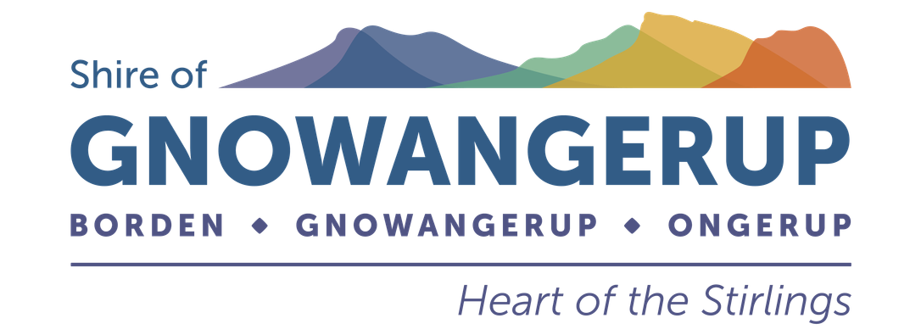

DISABILITY ACCESS AND INCLUSION PLAN (DAIP)

2026–2031

This plan is available in alternative formats such as electronic, hard copy in both standard and large print, by email and on the Shire of Gnowangerup website.

AT A GLANCE

Contents

Background
Shire profile, role, people with a disability and progress
The seven outcomes
- Access to services, facilities, information, service, complaints, consultation and employment

- Policy & development
Policy statement, planning responsibility and community consultation

- Reporting & questions
How the plan is communicated, implemented and reported

- Implementation plan
Strategies and annual actions for 2026/27–2030/31

OUTCOME 1–7
The seven desired outcomes remain the framework for this plan.
The modernised document keeps the original DAIP structure and wording as the content base, while presenting it in a cleaner, more contemporary format.

01 | BACKGROUND

Shire of Gnowangerup

The Shire of Gnowangerup is situated in the Great Southern region of Western Australia, approximately 354 kilometers from Perth and 140 kilometers from Albany via Chester Pass Road. It covers an area of approximately 5,000 square kilometers and is a prosperous grain growing and sheep producing area. The area is noted Australia wide for its merino sheep.
There are three towns in the Shire of Gnowangerup (Gnowangerup, Ongerup and Borden) which service the local community and a growing tourism node at the edge of the Stirling Range National Park.
The Shire of Gnowangerup provides the community with a range of services including infrastructure such as roads, public buildings, drainage infrastructure and a sealed airstrip. The Shire also provides community services such as three sport and recreation centres and a public swimming pool, library services, parks and economic and community development services.
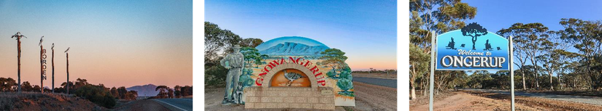

The Shire of Gnowangerup’s Role
The Shire of Gnowangerup is responsible for a wide range of functions, facilities and services. These include the provision of roads, footpaths and waste collection. Facilities include:
- Gnowangerup and Ongerup Libraries;
- Borden Pavilion, Gnowangerup Sporting Complex and Ongerup Sporting Complex;
- Gnowangerup Community Swimming Pool;
- Gnowangerup Shire Medical Practice;
- Gnowangerup Aerodrome; and
- Gnowangerup and Ongerup Cemeteries.

01 | BACKGROUND

The development and implementation of this plan aligns with the Shire of Gnowangerup’s Council Plan 2025 – 2035. It sits under Objective 1 of the Council Plan; Our Community – Vibrant, connected community, promoting well-being and inclusion, particularly strategy 1.2 Accessibility to all community spaces and facilities.
It also sits under Objective 4 of the Council Plan; Leadership and Governance – Providing strategic leadership and effective advocacy for the advancement of our district, particularly strategy 4.2 An efficient and effective organisation, providing appropriate services to our community.

People with a disability in the Shire of Gnowangerup

According to the Australian Bureau of Statistics (ABS) 2016 census, the residential population of the Shire of Gnowangerup is approximately 1215. In Australia there are 4.4 million people living with disability. This represents 17.7% of the population.
If the 17.7% percent of Australian living with disability is extrapolated onto the Shire of Gnowangerup population, it may be assumed that 215 people within the Shire are living with disability.
At the time this document was composed, the 2026 census results had not been published. They will be incorporated into a later version.

Progress

The Shire has a DAIP working group which regularly reviews and updates progress on the DAIP. The Shire also reports annually on the outcomes of its 2021/26 DAIP to the Department of Communities.

The Shire of Gnowangerup is continuing to deliver or has successfully completed all the objectives contained in the 2021/26 DAIP. The 2021/26 DAIP Implementation Plan formed the basis to develop the 2026/31 version. The 2026/31 Implementation Plan contains deliverable objectives that have been decided upon following a public consultation exercise. Some of the objectives are a continuation of the ones contained in the 2021/26 Plan whilst some are building upon the successes of the previous Plan and aiming to make further improvements.

Progress & achievements

OUTCOME 1
People with a disability have the same opportunities as other people to access the services of, and any events organised by, a public authority.

- All events, including Wild Gravel and Fields & Fortunes, are accessible
- Shire now has a dedicated Communications Co-Ordinator who actively promotes all Shire events to all members of the community on several platforms.
- Audit undertaken of the entire Shire footpath network
- Customer Services staff frequently help customers to fill out forms. All public surveys are DAIP compliant. Snap, Send, Solve introduced, giving a more accessible way for residents to report issues.

OUTCOME 2
People with a disability have the same opportunities as other people to access the buildings and other facilities of a public authority.

- Audit of all Shire building undertaken and works carried out to ensure all buildings, where possible, are DAIP compliant and accessible.
- A detailed review of all ACROD parking allocations was undertaken. Existing sites in Gnowangerup upgraded to current standards and a new bay installed at the Shire admin building car park.
- Annual footpath audit now carried out.

OUTCOME 3
People with a disability receive information from a public authority in a format that will enable them to access the information as readily as other people are able to access it.

  - The Shire has had an increased presence at local events as part of the continued improvement of how it delivers information to the public. Google translate added to the website.
  - Community Development trained at using resources for CALD member of the community. Some resources offered to CALD leaders in their preferred languages.
  - Public documents, including the Annual Report and the Community Welcome Pack, are now DAIP compliant.
  - Website refreshed and improved in 2025.

OUTCOME 4
People with a disability receive the same level and quality of service from the staff of a public authority as other people receive from the staff of that public authority.

    - Staff received training in disability and access issues.
    - The new employee induction process includes information on access and disability.

OUTCOME 5 People with a disability have the same opportunities as other people to make complaints to a public authority.

  - The Shire customer complaint form is designed with disability access formatting and is available on the ‘easy access’ toolbar on the Shire’s website.
  - Complaints policy updated. Staff receive on-going training on how to deal with complaints. Staff will accept disability advocacy where requested.
  - The introduction of Snap, Send Solve has made it easier for people with a disability to alert staff of an issue.

OUTCOME 6 People with a disability have the same opportunities as other
people to participate in public consultation by a public authority.
  - The CEO holds a monthly public consultation meeting in Gnowangerup, Ongerup and Borden. This is held in accessible building and advertised in several formats.
  - All community consultation is hosted in accessible building and advertised in several formats.

OUTCOME 7
People with a disability have the same opportunities as other people to obtain and maintain employment with a public authority.

  - The Shire ensures inclusive recruitment practices are used. All employment advertisements and packages are available in a range of print and electronic formats.
  - Job advertisements posted on the Shire website have features for people with vision and hearing impairments, to enhance the user access.

- | POLICY STATEMENT
The Shire of Gnowangerup is committed to furthering the principles and objectives featured in this report. These principles and objectives are an important step in improving the lives of people with a disability, their families and carers by achieving the desired outcomes that will allow equity for all community members.

- | DEVELOPMENT

Development of the Disability Access and Inclusion Plan

Responsibility for Planning Process
The responsibility for developing, monitoring, implementing, reviewing and amending the DAIP sits with the Shire’s Community and Economic Development Manager and the Managers and Executives Committee (MANEX).
All managers are responsible for ensuring the plan is rolled out throughout the organisation and that actions are integrated into the relevant council areas.

Community Consultation

In 2026, the Shire reviewed its Disability Access and Inclusion Plan, along with the Implementation Plan, with the assistance from the community and drafted a new plan to further guide improvements to access and inclusion, and meet the requirements of the Disability Services Act 1993.
The consultation process included:
  - A review of the Shire’s current DAIP;
  - Consultation with the community and Shire staff members via a community questionnaire
  - The review of the current DAIP and Implementation Plan was workshopped at the Shire’s DAIP working group and a new draft DAIP was issued for Council consideration and public consultation.

Findings from the consultation
The consultation process provided feedback from the community on access and inclusion within the Shire of Gnowangerup. The main issues raised were;
- The Shire needs to be more aware of unseen disabilities such as autism, including better signage on toilets.
- Footpaths need further improvement including the prevention of vehicles parking on them and better accessibility for wheelchairs/mobility scooters.
- More education needed in neurodiversity.
- Having resources available in large print and access to translation services.
- More accessible play equipment in the park.
- Make Council meetings more accessible.

Communicating the plan

Once adopted by Council, this plan will be lodged with the Department of Communities.
The Shire of Gnowangerup makes its current DAIP available to the community via website, Facebook page, Library and Shire Office. Upon request, alternative formats such as electronic, hard copy in both large print and standard print and via email are available.
A public notice will be published on the website, Facebook Page and in newsletters within the Shire advising when the final DAIP is endorsed by Council.

Responsibility for implementing the DAIP

Implementation of the DAIP is the responsibility of all areas of the Shire. The Disability Services Act (1993) requires all public authorities to take all practical measures to ensure that the DAIP is implemented by its officers, employees, agents and contractors.

- | REPORTING

Monitoring & reporting
The Department of Communities sets out the minimum reporting requirements for public authorities in relation to DAIPs. The Shire of Gnowangerup will report on the implementation of its DAIP through its annual report and on the prescribed progress report template to the Department of Communities each year, outlining:
  - Its progress towards the desired outcomes of its DAIP;
  - The progress of its agents and contractors towards meeting the seven desired outcomes; and
  - The strategies it used to inform its agents and contractors of its DAIP.

The 2026/31 DAIP and Implementation Plan will be monitored and updated by the Shire’s DAIP working group, on a biannual basis and reported to Council annually.

QUESTIONS
Any questions relating to this plan can be addressed to the Community and Economic Development Manager, Shire of Gnowangerup by calling 08 9827 1007 or emailing gnpshire@gnowangerup.wa.gov.au.

ITEM
STRATEGY
RESP. OFF.

