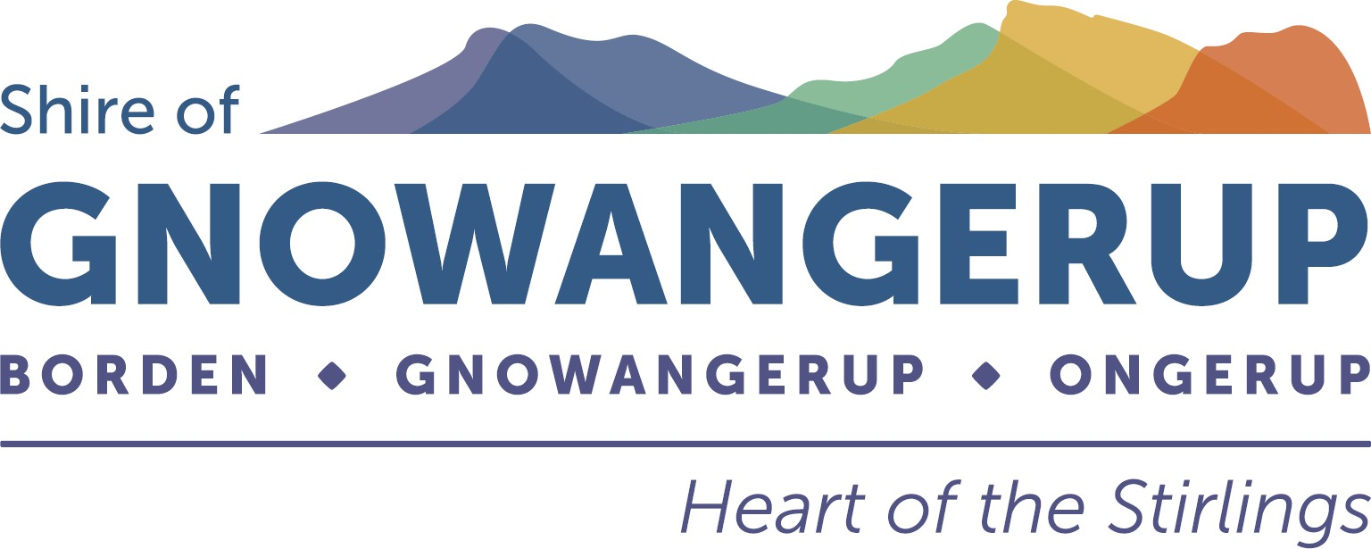

Shire of Gnowangerup
Community Grants Application Form
This application form is aligned with the Shire’s assessment criteria. Applicants should clearly address each question to assist assessment.

Funding Stream
- Small Community Grant (up to $5,000)
- Major Community Grant ($5,000–$10,000)

Organisation Details
Organisation / Group Name:

ABN (if applicable): Is your organisation incorporated? ☐ Yes ☐ No

If not incorporated, name of auspicing organisation:

Contact Person: Position: Phone:
Email:
Brief description of your organisation (what you do and who you support):

Project Overview
Project Name:

Project Location: Proposed Start and End Dates: Describe the project you are seeking funding for (what you will do):

Assessment Criteria
  - Community Benefit
Who will benefit from this project, approximately how many people, and what difference will it make to the community?

  - Alignment with Community Priorities
How does this project support the Shire’s Strategic Community Plan priorities (e.g. vibrant, connected community, promoting wellbeing and inclusion)?

  - Need for Funding
Why is Shire funding required? Would the project proceed without this funding?

  - Capacity to Deliver
Describe your organisation’s experience, volunteers, partnerships or planning that demonstrates your ability to successfully deliver this project.

  - Value for Money
Explain why the project represents good value for money and how costs have been kept reasonable.

  - Community Contribution

Describe any cash or in-kind contribution (volunteers, fundraising, sponsorship, equipment, venue).

  - Sustainability (Major Grants only)
Will the project continue after the grant funding ends? If yes, explain how.

Project Budget
Item | Cost ($)

Total Project Cost: $
Amount Requested from the Shire: $

Declaration
I certify that the information provided is true and correct and that the organisation agrees to comply with the Shire of Gnowangerup Community Grants Guidelines.
Name: Position:
Signature: Date:

